What It Means to be Human #5

“The Problem of Sin (part 3)”

Ecclesiastes 1-2

Over fifty years ago, when I was just a year old, a British band called the Rolling Stones released a song, “(I Can’t Get No) Satisfaction.” It became an instant hit, has been re-recorded over fifty times by other artists, and even generations who weren’t even born when the song originally hit the airwaves can still recognize it. It has been said that this song could easily have been the anthem of the 1960s as people all around the world seemingly tried everything to find happiness and fulfillment in life, yet came up empty.
The Rolling Stones were not the first to put such a sentiment in poetic verse, however. Consider this little ditty from Ecclesiastes 1:2, 14,

Meaningless! Meaningless!
Utterly meaningless!
Everything is meaningless…
A chasing after the wind.

If you recognize the words but can’t quite place the tune, relax. This was never a hit song on “American Bandstand.” In fact, it’s not known if this was ever put to music at all. But the words serve as an introduction to the account of one man who had it all, yet could sing along with Mick Jagger, “I can’t get no satisfaction.” And he’s not alone.
As we continue our series, “What It Means to be Human,” I want to spend one more week on the problem of sin. We have considered how sin entered the world and the devastation sin brought with it. In our last study we looked at how sin has corrupted every aspect of our being and ultimately leads to death.
This morning I want to look at another side of the sin problem—the emptiness of the life lived in sin. We might be tempted to think, “If only I had more [money, status, education] or had better [looks, brains, opportunities], then I could really be happy!” Yet the book of Ecclesiastes proves that theory to be completely wrong. The subject of the book—King Solomon—literally had it all, and this journal records his pursuit of purpose and fulfillment outside of God…and its utter failure.
Solomon introduces his account in Ecclesiastes 1:12-14,

I, the Teacher, was king over Israel in Jerusalem. I devoted myself to study and to explore by wisdom all that is done under heaven. What a heavy burden God has laid on men! I have seen all the things that are done under the sun; all of them are meaningless, a chasing after the wind.

The key phrases of this text—and the whole book—are “under the sun” (used 29 times throughout Ecclesiastes) and “under heaven” (used 3 times). These mean “without God” or “without consideration of God.”
In the first part of this book, Solomon goes through what Chuck Swindoll calls a “mid-life crisis.” He really went for it! With unrestrained determination he set out on a pursuit to find a purpose in existence.
And because he was a king, he could try everything in life his heart desired. Remember how, when Solomon first became king, God offered him anything he wanted. Solomon chose wisdom, which God granted, but because he chose so wisely God also blessed him with unequaled peace and prosperity during his reign. He had it all!
Look at his story in Ecclesiastes 1:16-2:11,

I thought to myself, “Look, I have grown and increased in wisdom more than anyone who has ruled over Jerusalem before me; I have experienced much of wisdom and knowledge.” Then I applied myself to the understanding of wisdom, and also of madness and folly, but I learned that this, too, is a chasing after the wind. For with much wisdom comes much sorrow; the more knowledge, the more grief.
I thought in my heart, “Come now, I will test you with pleasure to find out what is good.” But that also proved to be meaningless. “Laughter,” I said, “is foolish. And what does pleasure accomplish?” I tried cheering myself with wine, and embracing folly—my mind still guiding me with wisdom. I wanted to see what was worthwhile for men to do under heaven during the few days of their lives.
I undertook great projects: I built houses for myself and planted vineyards. I made gardens and parks and planted all kinds of fruit trees in them. I made reservoirs to water groves of flourishing trees. I bought male and female slaves and had other slaves who were born in my house. I also owned more herds and flocks than anyone in Jerusalem before me. I amassed silver and gold for myself, and the treasure of kings and provinces. I acquired men and women singers, and a harem as well—the delights of the heart of man. I became greater by far than anyone in Jerusalem before me. In all this my wisdom stayed with me.
I denied myself nothing my eyes desired; I refused my heart no pleasure. My heart took delight in all my work, and this was the reward for all my labor. Yet when I surveyed all that my hands had done and what I had toiled to achieve, everything was meaningless, a chasing after the wind; nothing was gained under the sun.

Can’t you almost hear him sing that hit song, “I can’t get no satisfaction”? After having searched the same places we search—intellectual pursuits, pleasure, social and material achievement—he concluded that there was no real satisfaction to be found in any of them.
Solomon’s experience was not unique. Though he had access to everything—so that no one could come along later and say, “Well, if he had a little more money, or a little more pleasure, or a little more power and prestige.” He had it all—and it all meant nothing when it came to fulfillment in life.
This, too, is part of the problem of sin that affects each and every one of us.

The Essential Qualities
This morning I want to illustrate how this works in our lives. To do so, I am using a chart taken from an excellent book by Larry Crabb, Effective Biblical Counseling. This was a textbook for a college course I took, and I have found it helpful in understanding how we operate. The overall chart looks like this, and we will break it down part by part:

The chart begins with the box in the upper center marked “Personal Needs.” People have one basic personal need which requires two kinds of input for satisfaction. The most basic need is a sense of personal worth, an acceptance of oneself as a whole, real person. The two essential qualities are significance (purpose, meaningfulness, or importance) and security (love—unconditional and consistently expressed; permanent acceptance). Crabb writes, “My experience suggests that although men and women need both kinds of input, for men the primary route to personal worth is significance and for women the primary route is security.” This is not an absolute statement—both men and women need both significance and security—but this is a fair distinction.

I believe that before the Fall, Adam and Eve were both significant and secure. From the moment of their creation their needs were fully met in a relationship with God unmarred by sin. Significance and security were qualities already resident within their personalities, so they never gave them a second thought. When sin ended their innocence and broke their relationship with God, what formerly were attributes now became needs. After the Fall Adam hid from God, fearing His rejection. They both blamed another for their sin, afraid of what God might do. They were now insecure. The earth was cursed and Adam was instructed to work by the sweat of his brow. There was now a struggle between man and nature. Would Adam have the strength to handle the job? He now was wrestling with threatened insignificance.

Ever since, mankind enters the world with these two essential qualities unmet. We spend our lives trying to build significance and security in our lives. These are primarily emotions—we need to feel significant and secure. This is a “God-shaped vacuum” in us.

The Endless Quest
Now we begin what I am calling the endless quest for fulfillment. We begin with our two essential qualities—significance and security—which are unmet because we are broken off from God by sin. Spoiler alert: These needs of security and significance can only be satisfied by a personal relationship with God. But what Solomon experienced in Ecclesiastes, and what I am illustrating today, is the attempts of man to meet those needs outside of God, or “under the sun,” as Solomon put it.
The first step in the process is motivation.

Motivation has been defined as “the purposive emotional forces that prompt persons to undertake various kinds of activity.” I disagree with the word “emotional” in that definition. While the needs of significance and security could rightly be classified as feelings, motivation is more. Motivation is a word referring to the energy or force that results in specific behavior. Before it becomes specific behavior, however, motivational energy is channeled through the mind. It is there that the energy assumes direction. I am motivated to meet a need by doing certain things which I believe in my mind will meet that need. Simply stated, motivation is the drive or urge to meet my needs. It is that sense of momentum which impels me to do something to become significant and secure. As a fallen people we experience an acute, keen desire to be significant and secure. We are willing to expend tremendous personal energy in an effort to satisfy these needs. We call this profound, compulsive willingness to meet needs motivation.
Our motivation—to feel significant and secure—leads to basic assumptions of how those needs can be met.

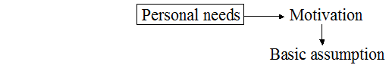

Now, remember, we are talking about people who do not look to God to meet their essential needs. And so they try to meet their own needs. Examples commonly seen are:

“I will be significant if…
… I have money;
… I excel;
… I never fail or make a mistake;
… my kids turn out well.”

or, “I will be secure if…
… I have a loving spouse;
… I am never criticized;
… everyone accepts me.”

People pursue irresponsible ways of living as a means of defending against feelings of insignificance and insecurity. In most cases these folks have arrived at a wrong idea as to what constitutes significance and security. And these false beliefs are at the core of their problems. Wrong patterns of living develop from wrong philosophies of living. “As [a man] thinks in his heart, so is he” (Prov. 23:7). The obvious problem may be one’s behavior, but the core issue is one’s beliefs. You will not correct the problem by exhorting responsible behavior. A change in thinking is required. But I’m getting ahead of myself…
Once a person latches on to a basic assumption he or she believes will meet their need(s), their motivation requires direction. A goal is set.

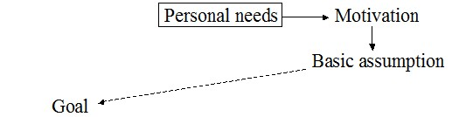

The goal is a specific objective based on the basic assumption. If I assume that I will be significant if I excel, the my goal may be to be the top student in the class or the CEO of the company or the best ever at my position. If I assume that I will be secure by having everyone accept me, then my goal will be to please everyone and offend no one.
The next step is goal-oriented behavior. What must I do to achieve my goal?

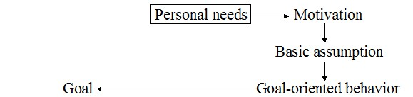

Goal-oriented behavior can be intelligent, realistic, and sensible or it can be ignorant, unrealistic, and utterly ineffective. The goal therefore may not be reached, the person will feel threatened as his needs remain unmet, and he will become anxious or resentful.

The Eventual Quandary
This brings us to what I am calling the eventual quandary—the dilemma the one who tries to find significance and security. This manifests itself in three different ways.
On the way to achieving the goal, an obstacle may get in the way.

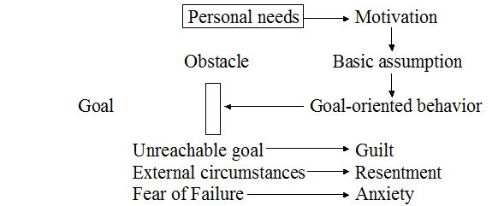

Whenever someone encounters an obstacle on the road to a desperately desired goal, they experience frustration. The emotional form the frustration assumes depends on the nature of the obstacle encountered. The obstacle may be an unreachable goal, which results in feelings of guilt; external circumstances beyond one’s control, which results in feelings of resentment; or a fear of failure, which results in feelings of anxiety.
Some will try to overcome the obstacle and to reach the fervently desired goal (change spouse, live perfectly, make money, etc.). The effectiveness of his goal-oriented behavior will be evaluated and new strategies that hold promise of crossing the barrier and reaching the goal may be adopted.
Others, labeled “neurotics” by Dr. Crabb, are no longer trying to overcome the obstacle. Their goal is safety. They have tried time and again to reach the goal that they believe is essential to his significance and security. Rather than pursuing goals that they believe would provide self-worth, they now begin to direct their efforts toward protecting whatever self-esteem may remain. They give up the fight to become worthwhile and move into a holding pattern: hold on to whatever self-esteem you have. Don’t try for more—you’re asking for more frustration. In the extreme cases where there is no sense of worth at all, the individual retreats into psychosis—a complete break from a painful world. In essence the psychotic is saying, “I’ve had enough pain. I want no more. I will withdraw entirely into the only safety zone I have—unreality.”
Many people are, in these terms, living in the pre-neurotic stage. They are angry with their world (resentment), or they feel down on themselves (guilt), or they live under a cloud of consistent tension and fear (anxiety). They still keep on trying, plodding along in a daily, grudging routine. Christianity is a “grind it out” experience in which these people bravely endure an unhappy life, forcing an occasional “Praise the Lord anyway,” and wondering what the joy of the Lord really is. Perhaps some of you can relate to these experiences.
What about those who try and try to meet their goal and fail? The failure leads to despair, and that despair can—in extreme cases—lead to suicide.

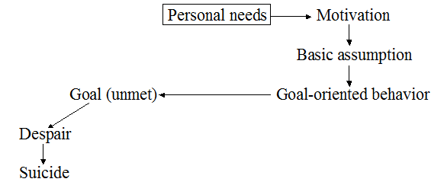

Others are able to accomplish their goal, like Solomon did in achieving ultimate wealth, wisdom, work, and pleasure. This leads to satisfaction, but it is partial and temporary. The “thrill of victory” doesn’t last, and it doesn’t meet our deepest needs.

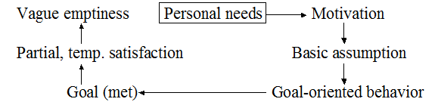

This is what led Solomon to declare, “Everything is meaningless.” It wasn’t that he didn’t have enough wealth, wisdom, work, or pleasure. He had it all! But it didn’t satisfy. Ravi Zacharias observes,

What seems so difficult for many to grasp is that pleasure is always momentary. You can time it on every occasion. It has no staying power. That’s what happens “under the sun”—apart from God. All pleasure, however good, is locked into the sensation of the moment. Was the pleasure in keeping with the way My Father has framed you? If it’s in keeping with His will, the mark it leaves upon your conscience will draw you back again to the pleasure, only this time it is pursued for a greater purpose than immediate gratification.

Solomon discovered that you can have power, wealth, wisdom, and opportunity—all the things that make up what the world calls success—but if you don’t have God, life doesn’t satisfy you or even make sense.
Horizontal happiness won’t last. That’s the whole point of Solomon’s journal—and that’s what makes his words so relevant. Change the names, the geography, the year, the culture, and you’ve got today’s scene portrayed in living color. It only intensifies the further you go into his journal.
This brings us back to where we started—those personal needs of significance and security. Those who are ambitious may start over by changing the basic assumptions and goals and trying again. Others may try to escape by getting drunk (or high) in order to escape the pain.

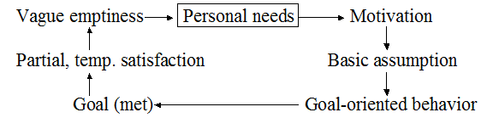

Nothing ultimately brings satisfaction if it is limited to “life under the sun.” Satisfaction in life under the sun will never occur until there is a meaningful connection with the living Lord above the sun. Nevertheless, we, like Solomon, continue to try to find meaning in life, only to wind up on a dead-end road called Emptiness.
The good life—the one that truly satisfies—exists only when we stop wanting a better one. It is the condition of savoring what is rather than longing for what might be. The itch for things, the lust for more—so brilliantly injected by those who peddle them—is a virus draining our souls of happy contentment. Have you noticed? A man never earns enough. A woman is never beautiful enough. Clothes are never fashionable enough. Cars are never nice enough. Gadgets are never modern enough. Houses are never furnished enough. Food is never fancy enough. Relationships are never romantic enough. Life is never full enough. Satisfaction comes when we step off the escalator of desire and say, “This is enough. What I have will do. What I make of it is up to me and my vital union with the living Lord.”
A person who does not have Christ at the center of life can never be truly satisfied. Regardless of how much he or she sees or hears, owns or experiences, it is never enough. There will always be that craving for more. Why? Because there is an empty spot in our lives that only God can fill. No amount of activity or success can ever fill it in His absence.
The psalmist writes, “Delight yourself in the Lord and he will give you the desires of your heart” (Psalm 37:4). God has reserved the privilege of bringing satisfaction and meaning to our lives for Himself. We will not find it anywhere else.
It is my hope that this diagram helps us better understand the essential qualities of significance and security in our lives, and how trying to satisfy them outside of God leads us on an endless quest that leads to the eventual quandary of disillusionment with life.

Kenneth L. Barker, ed., The NIV Study Bible (Grand Rapids, MI: Zondervan, ©1985)
Charles R. Swindoll, Living on the Ragged Edge (Dallas: Word Publishing, ©1985).
Robert S. Ricker, Soul Search, A Bible Commentary for Laymen (Ventura, CA: Regal Books, ©1983, 1985).
Lawrence J. Crabb, Effective Biblical Counseling (Grand Rapids, MI: Zondervan, ©1977).
Crabb, op. cit.
Crabb, op. cit.
Crabb, op. cit.
“Motives and Motivation,” in R. K. Harrison, Encyclopedia of Biblical and Christian Ethics (Nashville: Thomas Nelson, ©1992).
Crabb, op. cit., emphasis added.
Crabb, op. cit.
Crabb, op. cit.
Ravi Zacharias, Sense and Sensuality (Colorado Springs, CO: Multnomah Books, ©2006).
Warren W. Wiersbe, Life Sentences (Grand Rapids, MI: Zondervan, ©2007).
Swindoll, op. cit.
Swindoll, op. cit.
Ricker, op. cit.

